Java Wrapper Classes

Wrapper classes provide a way to use primitive data types (int, boolean, etc..) as objects.

The table below shows the primitive type and the equivalent wrapper class:

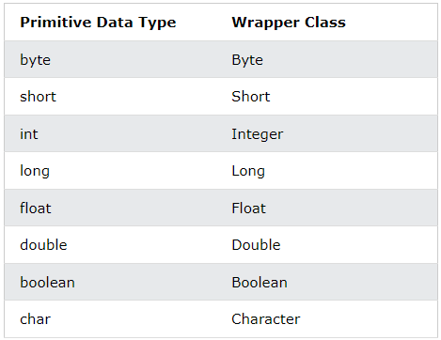

Sometimes you must use wrapper classes, for example when working with Collection objects, such as ArrayList, where primitive types cannot be used (the list can only store objects):

### **Example**

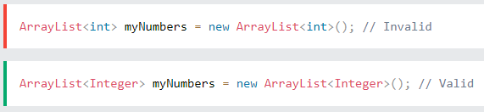

## Creating Wrapper Objects

To create a wrapper object, use the wrapper class instead of the primitive type. To get the value, you can just print the object:

### **Example**

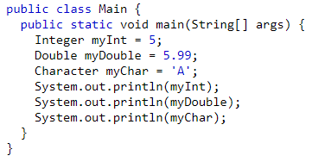

Output:

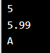

Since you're now working with objects, you can use certain methods to get information about the specific object.

For example, the following methods are used to get the value associated with the corresponding wrapper object: intValue(), byteValue(), shortValue(), longValue(), floatValue(), doubleValue(), charValue(), booleanValue().

This example will output the same result as the example above:

### **Example**

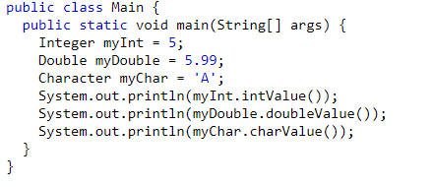

Output:



Another useful method is the toString() method, which is used to convert wrapper objects to strings.

In the following example, we convert an Integer to a String, and use the length() method of the String class to output the length of the "string":

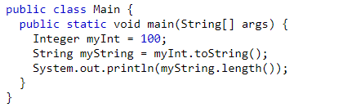

Output:



References

1. https://www.w3schools.com/java/java_wrapper_classes.asp